**REQUEST FOR PROPOSAL**

**REQUEST FOR PROPOSAL (RFP) NUMBER: 056878-0001**

**FOR**

**DESIGN CONCEPT**

**OF THE**

**Unmanned aerial vehicle (uav)**

**1st Report /Proposal ARE TO BE RECEIVED NO LATER THAN DATE:**

**January 29, 2015**

**LOCATION:**

**LOCKHEED MARTIN SPACE SYSTEMS**

**LSTTB – IDC Conference room**

**ATTENTION:**

***Benjamin Reese***

**303-596-6389**

[benjamin.j.reese@lmco.com](mailto:benjamin.j.reese@lmco.com)

# RFP Summary:

Unmanned Aerial Vehicles (UAVs), commonly known as a drone is an unpiloted aircraft or remotely piloted aircraft. UAVs have historically been used primarily in military applications, however their use in the civilian and commercial markets is on the rise. UAVs come in many shapes and sizes including traditional fixed wing planes, helicopters, quadcopters, and even gliders. Here at Titan Aerospace we are interested in developing a UAV platform that is remotely piloted and able to navigate and accomplish 5 different obstacle courses in under 15 minutes. Your design may be based off of any available UAV, examples of which are shown below:

|  |  |
| --- | --- |
| http://www.bitcraze.se/wp-content/uploads/2013/10/crazyflie_page.png | Crazyflie Nano Quadcopter. Image Curtesy of [www.bitcraze.com](http://www.bitcraze.com) |
| http://www.robotshop.com/media/catalog/product/cache/1/image/800x800/9df78eab33525d08d6e5fb8d27136e95/a/i/air-hogs-helix-x4-stunt-quadcopter.jpg | Helix X4 Stunt Quadcopter  <http://www.robotshop.com/en/air-hogs-helix-x4-stunt-quadcopter.html> |
| http://www.robotshop.com/media/catalog/product/cache/1/image/800x800/9df78eab33525d08d6e5fb8d27136e95/1/s/1si-ready-to-fly-quadcopter.jpg | **1Si Ready-to-Fly Quadcopter**  <http://www.robotshop.com/en/1si-ready-to-fly-quadcopter.html> |

# General Requirements:

* Vehicles shall have the following requirements:
  + Teams have a budget of $195.00 to purchase one or more UAVS to complete the 5 obstacle competition. The $195 limit is for costs associated with the purchase, construction, and modification of the final competition vehicle(s). You may use your own materials but their market value will count against your total budget. Market value will be determined by the advisors
  + All competition vehicles must be capable of flying under its own power.
  + The vehicle may be worked upon by the teams during the competition
  + No dimension shall be larger than 18" (minimum obstacle diameter)
  + Vehicles must be capable of flying up to 10’ off the ground
  + Vehicles must be piloted by a team member
  + Vehicles must be able to carry a payload of at least 20 grams
* Competition Requirements
  + Teams will have 15 minutes to complete as many challenges as possible, this includes any time needed to charge batteries or make modifications/repairs. The 15 minute timer will start when the vehicle starts the first challenge.
  + The UAV may only be touched when it is in the “pit” area of the challenge, once it enters the course it cannot be touched until returning to the pit area. Touching the UAV will result in a loss of all possible points for that particular challenge
  + See the Mission Description Section for detailed challenge requirements
* Designs will be judged based on the following criteria:
  + Creativity and Design
  + Performance
    - Number of Obstacles Successfully Completed
  + Time
* REIMBURSEMENT PROCESS – In order to be reimbursed for expenses incurred, up to a maximum of $195 per team, the following conditions must be met:
  + Team must participate in final team night and launch readiness review
  + Team must have a UAV on mission day
  + Keep receipts and itemize expenses
  + Team must return any borrowed equipment
  + Checks will be written on mission day only to those with itemized report and receipts
* Multimedia outbrief is required on the last meeting (Power Point, and/or videos and pictures)
* Have fun and be creative!

# Proposal Instructions

* Proposals need to be typed
* Proposal shall not exceed 8 pages, including cover sheet
* Proposal must include the following:
  + Sketches of idea
  + Schedule of design, build, test, and execution
  + Budget, itemized with total
  + Explanation of how your team will meet the RFP Requirements
  + Example Outline for Proposal:
  + Overview and Mission Statement
  + Technical Overview
  + Management and Cost Overview
  + Submit two copies on due date
  + Include one softcopy to email address on front of RFP
  + Retain one copy of proposal for your team
  + File format can be in Microsoft Word or PDF.
* **Overview-Section Instructions for Proposal**:
  + State your team’s design concept concisely
  + (Mission Statement)
  + Explain why your team’s design is the best
  + Propose why your team’s proposal should be chosen
* **Technical-Section Instructions for Proposal**:
  + Discuss your design
  + Illustrate your design and how it will work
  + Discuss the hardware you will need
  + Discuss how your team will build your concept into a prototype
  + Discuss how your team will test your design
  + Include any special features of your design
  + Include any formulas you intend on using.
* **Management and Cost Section Instructions for Proposal**:
  + Discuss how your team will meet the final acceptance date.
  + The proposal should include a schedule of events, such as:
    - Design Complete
    - Buy all hardware and parts
    - Prototype Design Complete
    - Final Design Testing Complete
    - Test run
    - Competition Date (05/02/2015)
  + Discuss what each team member's role is in your group.
  + You should include a brief description of each team member. Include phone numbers, school, addresses, special skills, etc.
  + Discuss how your team will keep its budget
  + Include a detailed, itemized budget with a description and source of parts

# Project Timeline:

**January 29, 2014 Proposals are due**

**February 12, 2015 Comments will be compiled and e-mailed back to team captain if not given at the meeting**

**April 23, 2015 Team Night & Launch Readiness Review**

**May 2, 2015 Tentative Mission Day, 8am**

**Time and day may be revised due to pool schedule**

*May 9 is back-up mission day*

**May 14, 2015 Multimedia Reports Due**

# Mission Description

## General Course Layout

There will be 5 unique courses, one for each challenge. The challenges may be completed in any order and attempted as many times as necessary within the allocated 15 minutes. In the event of a crash or mechanical failure that requires the vehicle to be touched outside of the pit area, the points for that obstacle will be forfeited. After making repairs, the team will be allowed to continue to attempt the remaining challenges until their 15 minutes expires. In order to successfully complete a challenge, the vehicle must complete the challenge objective and successfully return to the pit area.

An example layout of the challenge course is below:

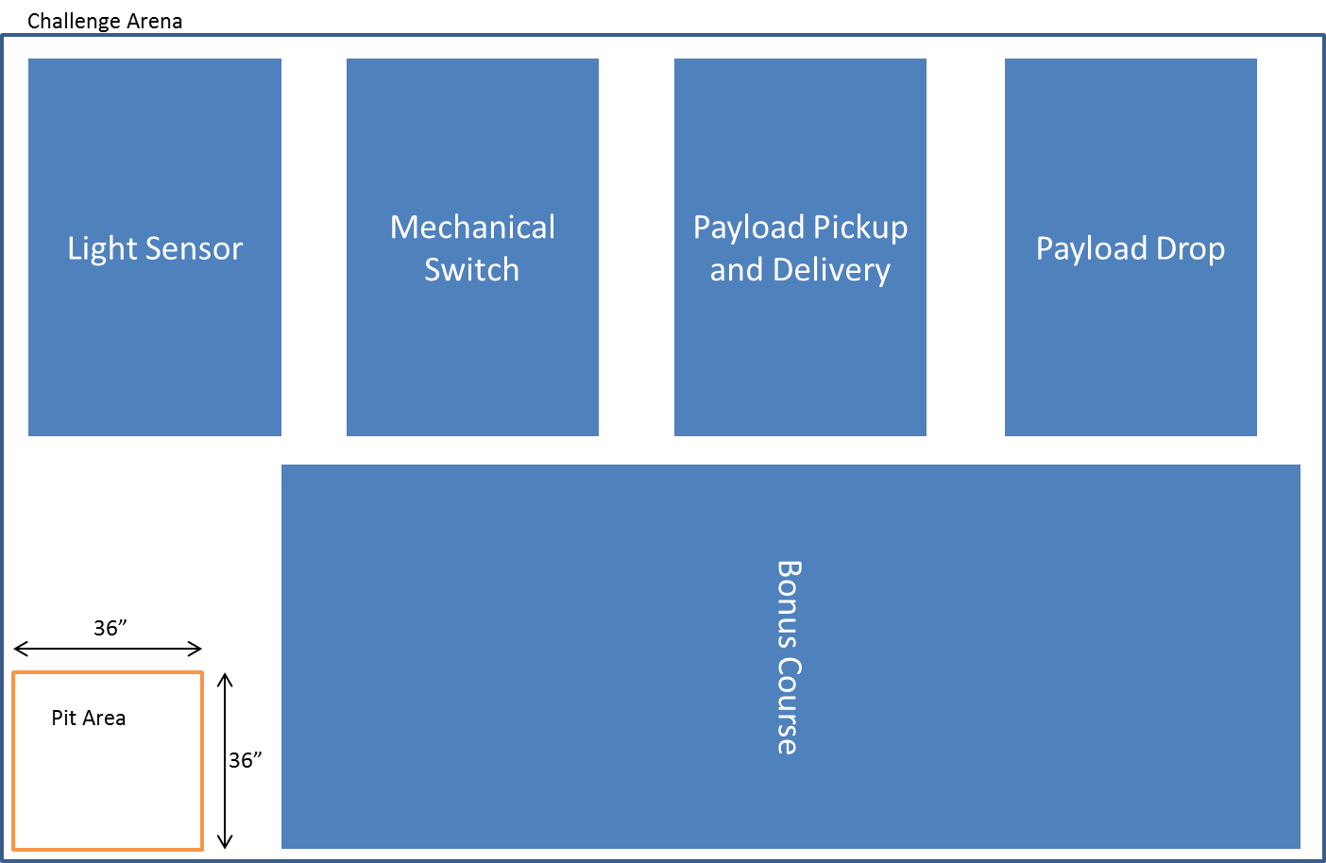

## Challenge 1: Light Sensor

The Light Sensor challenge will require the UAV to navigate a short obstacle course and shine a light on a photo-cell sensor. The sensor will be located approximately 3 feet off the ground. The sensor will be shielded to allow only light from one direction to hit the sensor.

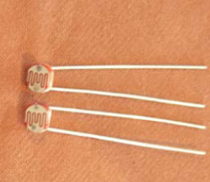 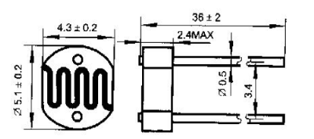 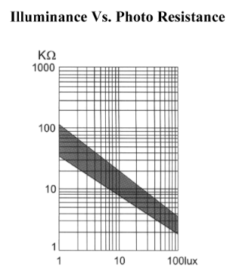



## Challenge 2: Mechanical Switch

The Mechanical Switch challenge will consist of a hinged metal rod that needs to be moved until it makes contact with an electrical pad, triggering a buzzer to sound. The switch will be located approximately 3 feet off the ground and will need to be moved until it closes the circuit and triggers the buzzer.

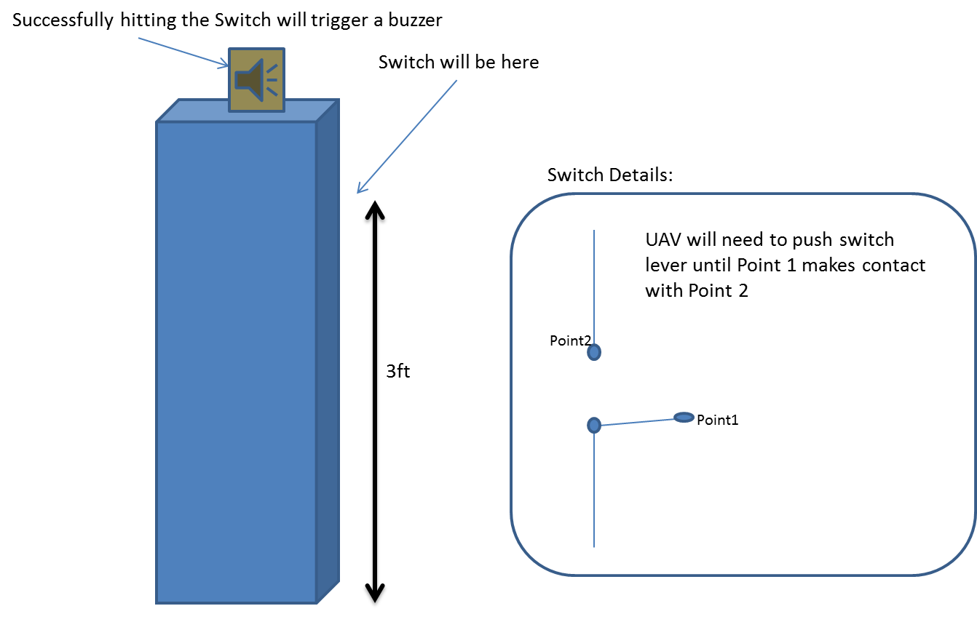

## Challenge 3: Payload Pickup and Delivery

The Payload Pickup and Delivery challenge will consist of the vehicle retrieving a paperclip from the course and returning it to the Team’s pit area. The paperclip may be dropped prior to landing, or remain connected to the vehicle after the vehicle has landed. In order to successfully complete the challenge both the paperclip and the vehicle must be in the pit area.

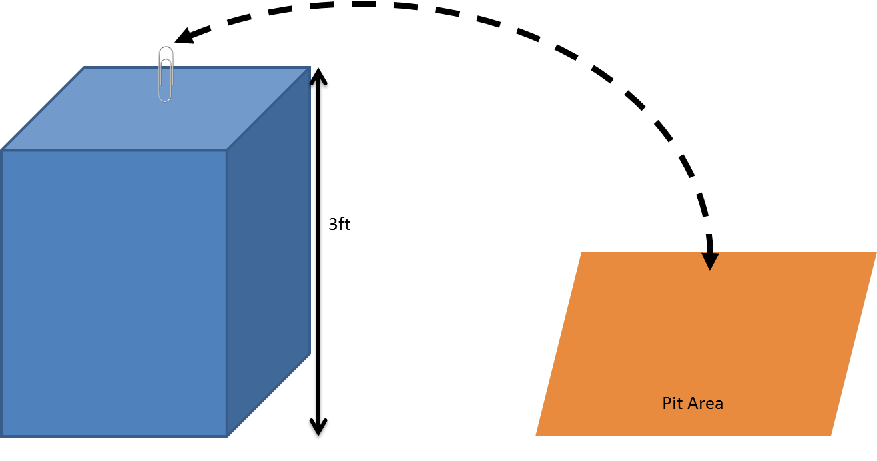

## Challenge 4: Payload Drop

The Payload Drop challenge will consist of dropping a green army guy on a target. The target will have a bullseye surrounded by two scoring rings. The army guy may be placed on the vehicle by team members while the vehicle is in the pit area, but must be remotely dropped on the target.

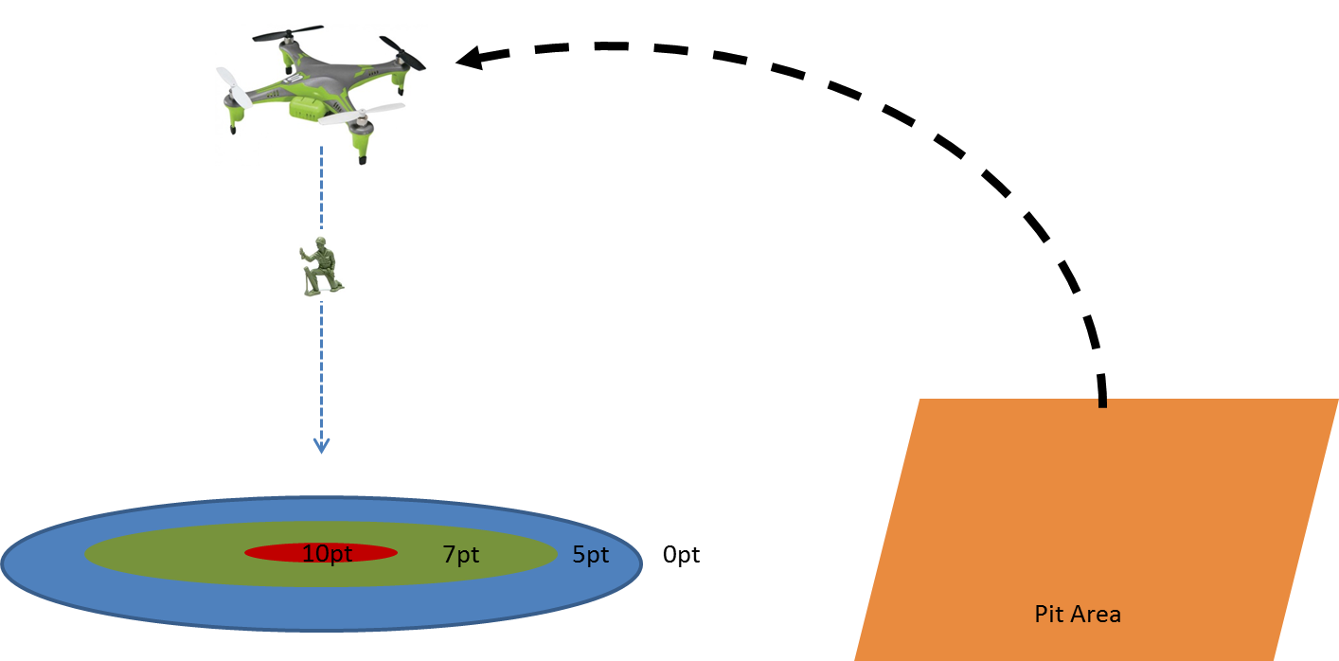

## Challenge 5: Bonus Course

The bonus course will only be attempted after all other obstacles. The teams score will be based on time and flight accuracy. The course and obstacles will not be known until the day of the competition.

