Build a Foam Rocket

- Take 2 strips of the duct tape and place them on top of each other

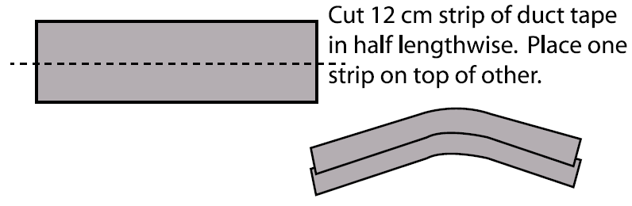

- Place the double duct tape piece thru the rubber band

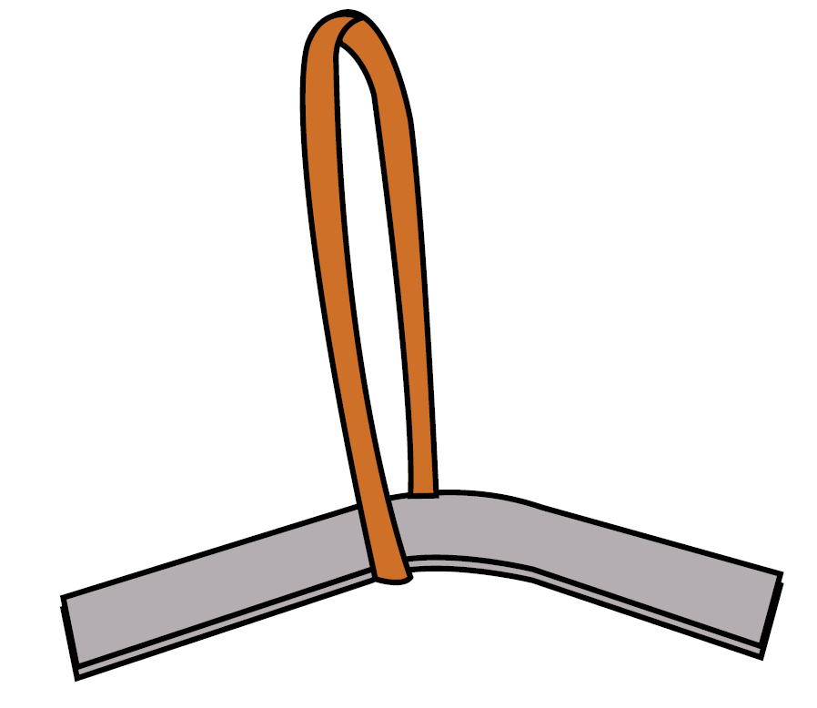

- Place the rubber band and duct tape strip on the non-cut end

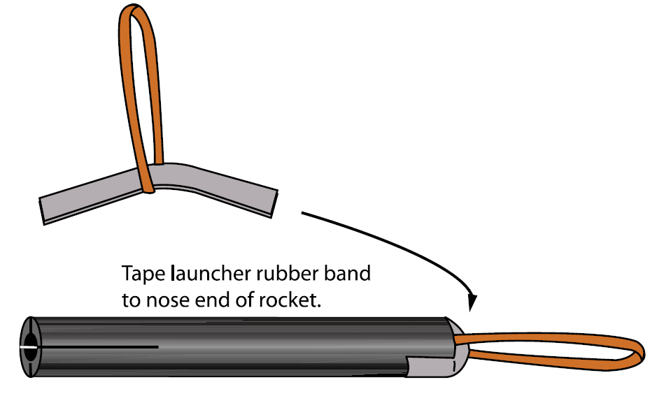

- Take 2 strips of the duct tape and place them around the nose with the rubber band

- Take the fins and place them into the slits on the other end

- Take more duct tape and tape the end

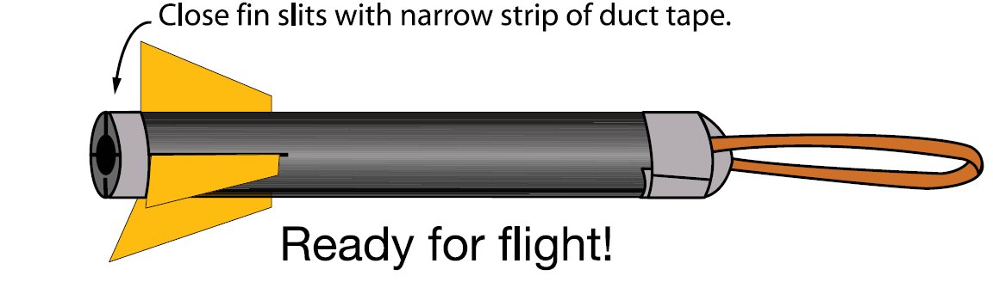

Rocket Intercept Experiment Team Name
Names

- The missile team member will record all the hits occurred. (Team members will switch jobs later)
- First Launch:
  - Interceptor Teammate – Attach the rocket to the launcher and pull back on the rocket base until the tail reaches the 23” mark. Tilt the rocket launcher until it is pointing upwards at an angle of 45°. Release the rocket when the launch command is given.
  - Missile Teammate – Attach the rocket to the launcher and pull it back on the rocket base until the nose reaches the 5” mark. Keep the launcher straight up (or at an angle of 90°). Release the rocket when the launch command is given. Record the angle of the interceptor and if the interceptor hits the missile.
- Repeat the launch procedures four more times. If you have a hit, then move to the next blue line
- Run the entire experiment one more time but switch the jobs. Try to get the same number of hits or more hits. You are working as a team; the more the team gets hits, the higher the score!
- Record your data:

Interceptor | Hit # |  | Missile | Hit #
Example | Miss |  | Example | Hit
1 |  |  | 1
2 |  |  | 2
3 |  |  | 3
4 |  |  | 4
5 |  |  | 5
Total Hits |  |  | Total Hits

Out of the 10 tries, how many hits did you get? What do you think you could have done differently?

Rocket Range Experiment Team Name
Names

- The planet team member will record all the hits occurred (team members will switch jobs later).
- First Launch:
  - Launcher Teammate – Attach the rocket to the launcher and pull back on the rocket base until the tail reaches the 23” mark. Tilt the rocket launcher until it is pointing upwards at an angle of 30°. Release the rocket when the LAUNCH command is given.
  - Planet Teammate – Give the LAUNCH command. Record the distance (closest mark) and whether or not the rocket hit the planet.
- Switch jobs. If you launched the rocket, go and pick it up and you now become the Planet Teammate.
- Run the entire experiment 4 more times but switch the jobs after each launch.
- Record your data:

Launcher | Angle | Distance | Hit
Example | 30° | 5 meters | No
1 | 30°
2 | 45°
3 | 60°
4 | 75°
 |  | Total hits

Out of the 4 tries, how many hits did you get? What do you think you could have done differently?

